Your Stationary Web House App

Harman deep Singh

Final Project

Section 1

# Task 1

Client Details

Client Name: Samarth

Email -Samrath123@gmail.com

Contact: 0225816564

## Primary Objective

The purpose of the Stationary house Web App is to make more strong marketing strategy for the client as to run the client business more and selling more products. By the Web App client can sell his products to the different parts of the world rather than selling locally. The Web App also Improves customer satisfaction rate and allows customer to give ratings about the products.

## Target Audience

The target audience for this project is the people who love to use stationery items and view their details. The age can go from 5 plus to 100 plus.

## Task 2- Requirements

Scope: The Web app scope is clean and clear as It has all the things required by client like Homepage, Category and Stationary page in the Web app which helps the customer to find the products according to their needs which they can do easily by accessing the category page. There is also a Register button to register for a new user as well as there is a login button for the customer to Log in and Log out of the Web App.

Cost: The We App cost was decided according to the requirements as I took $100 for each page for the client, and I buy the Domain from the crazy Domains website which costed about $250. I Downloaded the high-quality images which cost about $200 and all the content and graphics for the web app was cost $600 including the timeframe for Web App.

Time:

Planning: Firstly, after reading the project document I planned the designing and content for the web App in 4 days and around 3 hours each day.

Working: I started working on project after making the plans like Goals, Scope and Objectives and which took me 6 days to complete and 5 hours each day.

Making Database: Database was a tuff job for me as it took 8 days to complete by working 4 hours each day on it.

Finally Completing & Testing: After making the database I competed the Project and at last Tested that if all the features were working properly which took me 3 days to complete working 2 hour each day.

Project Management: Project management is the process in which we check the project made by us is working properly or not. So, the pages developed are defined below:

Homepage: Woking Fine and Opening. Brings back to main page from any page.

Categories: The page is working perfectly and in this page a customer can find product according to his needs by filtering the products.

Stationary Page: The page is working, properly and this page has the attached Images of the products and upcoming new products images as well.

Register Page: In this page any user can Register himself and add products in cart.

Login Page: After registering customer can Log in Any time to see the Updated Features of the Web App.

Risk Management: The risk management is any threats causing to our Web App.

Analysing: Risks in the Web App can be analysed by identifying the type of threat.

Making Action: After identifying the threat the developer should take some action to control or stopping the risk.

Keeping Eye: It is the responsibility of the developer to keep an eye on the risk, by finding the reason or making sure to control the risk from next time.

Breaking the Risk: A developer should use some tools and techniques in advance to control the future risks in the Web App.

Meeting with the client

In the client meeting I met the client and he told me all his requirements by giving some examples of online Web Apps, told me about the company and products also provided me high quality images for using in the Web App to raise more traffic on the Web App.

Task 3-Design Mock-ups

## Detail Design

### Home Page

The main landing page of the application. On navigation bar options are- Home, All Categories, All Stationery, Register, Login.

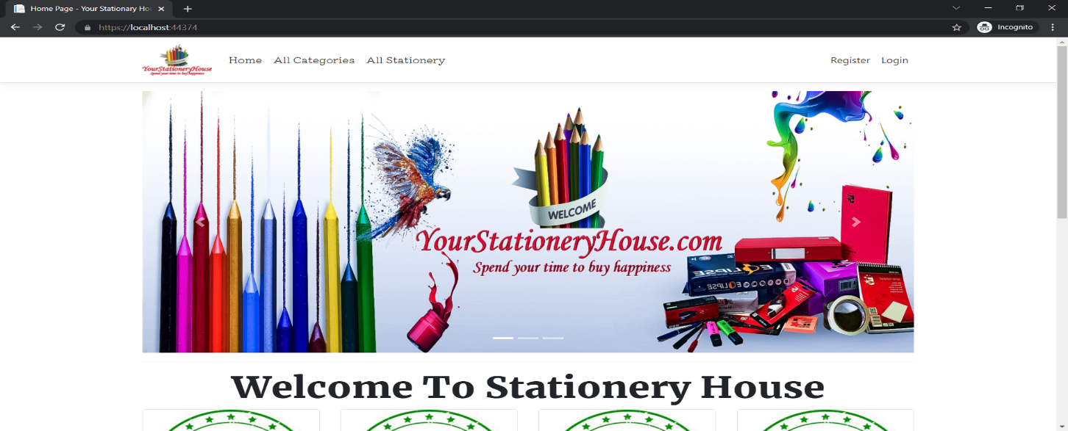

### Registration Page

With the help of this page, new registered visitor can sign up for the app

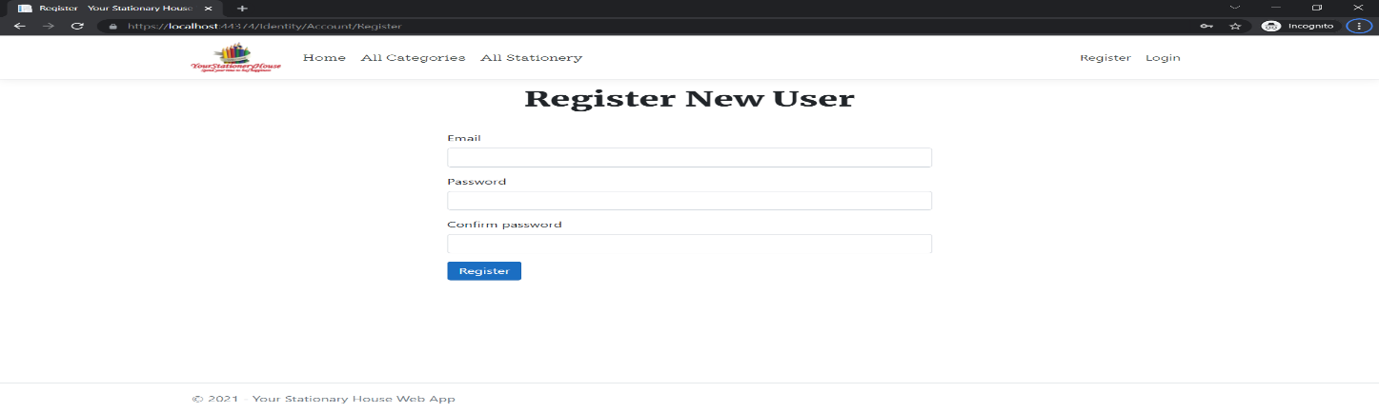

### Login Page

With the help of this page, registered visitor and admin can login to the application using their valid credentials.

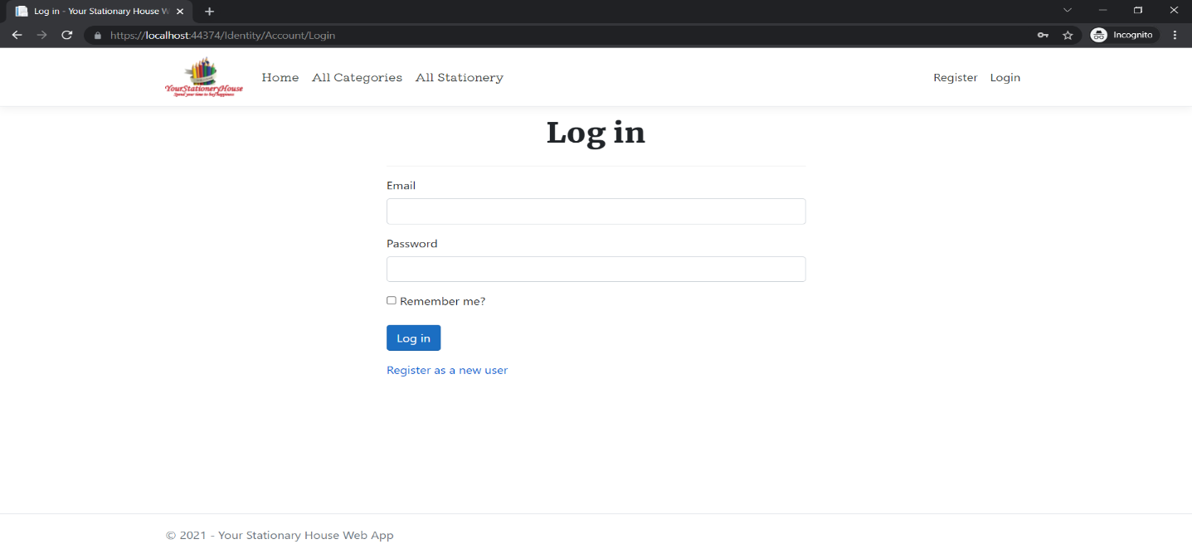

### All Categories Admin View

This page highlights all the categories available on the application. Admin can delete and check details of the existing ones.

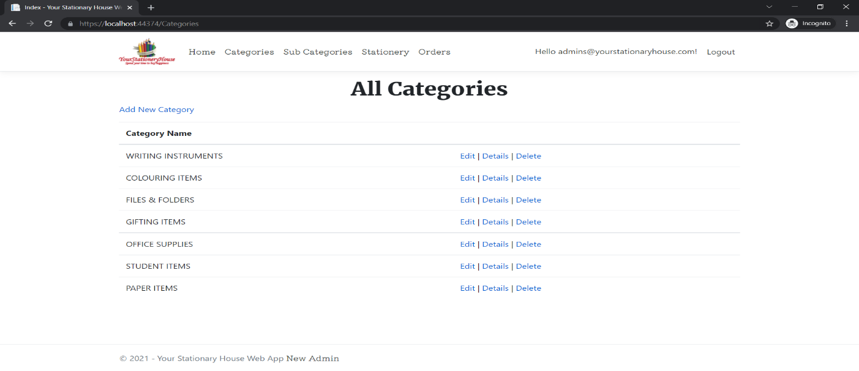

### All Stationery Admin View

With the help of this page admin can manage the stationery details by editing, deleting and checking their details.

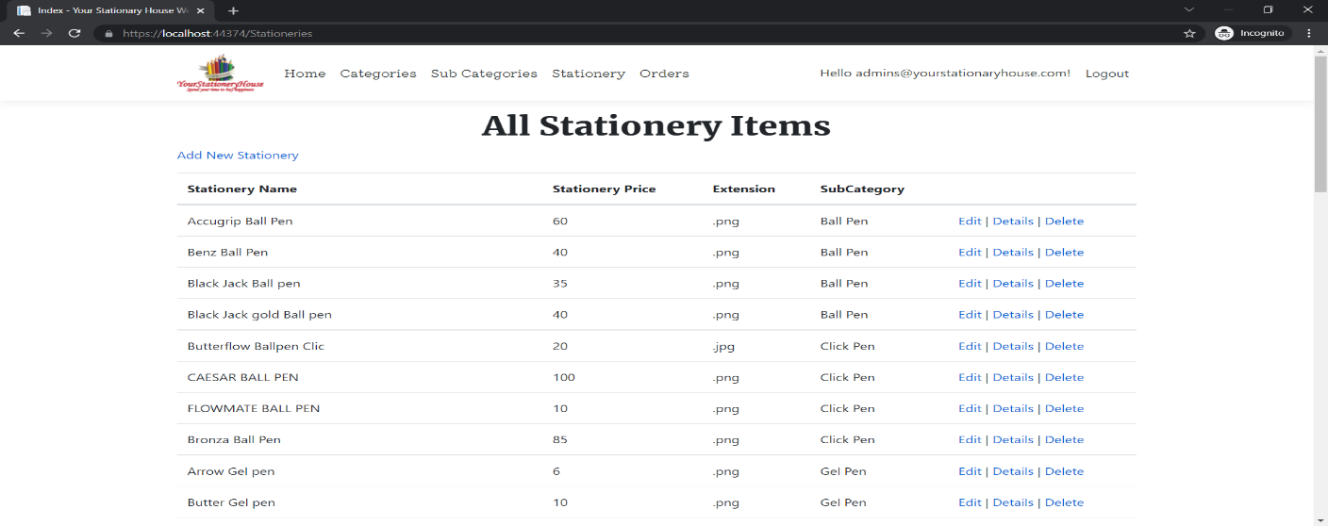

### All Categories Visitor View

With the help of this page Visitor can view All Category and Sub Category details.

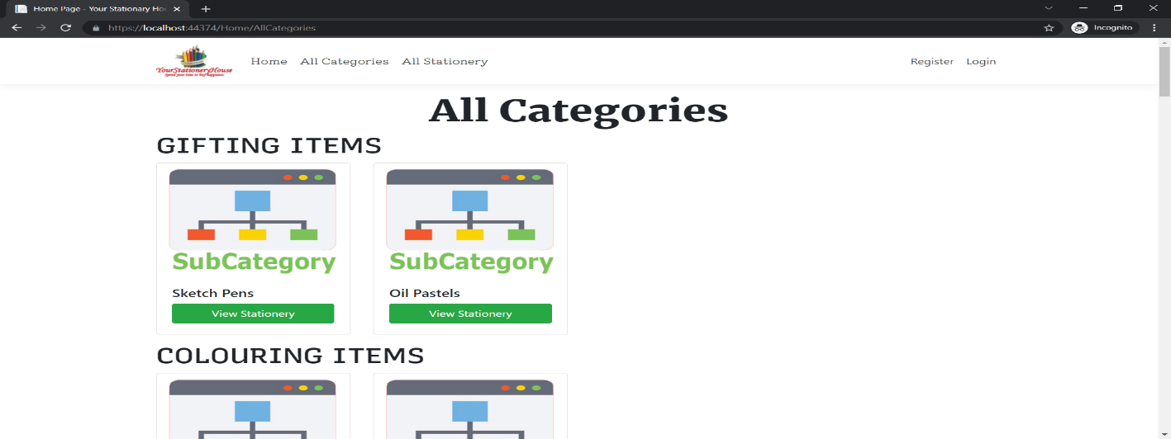

### All Stationery Visitor View

With the help of this page visitor can check the details of the Stationery and link to their Place Order.

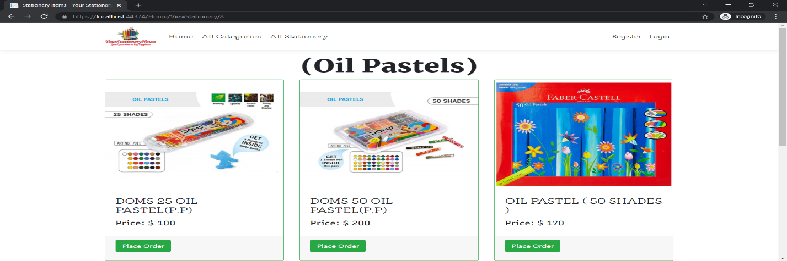

### Place Order Page Customer View

This page shows the Place Order of a particular Stationery Item after successful login.

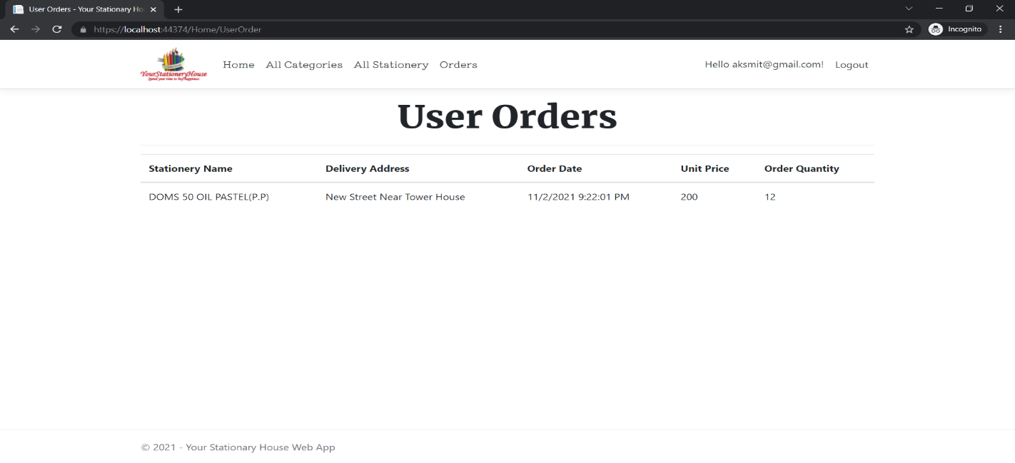

Section 2- Project Development

The Web App Project “Your Stationary House” is nice project with the High-quality Images and nice content. The rest of the project is uploaded on the git-hub YourStationaryHouseWebApp.sln

Task 4-Coding

The Coding and commenting for the Web App is attached in the YourStationaryHouseWebApp.sln file.

Task 5-Usability Testing

## Project Testing

The testing file for usability testing is attached as [usability test.xlsx](usability%20test.xlsx)

Task 6-Client Meeting

In the client meeting I met the client and he told me all his requirements by giving some examples of online Web Apps, told me about the company and products also provided me high quality images for using in the Web App to raise more traffic on the Web App.

Client Review Form:

Communication was excellent.

Progressed well.

Worked Completed on Time.

Updated Regularly.

Easy Communication.

Section 3-Presentation & Reflection

Task 7- Presentation

I have Submitted my presented video recording in Git-hub.

Task 8- Software Development

Planning: My first step towards the Web App Project was planning after reading the project documents after that which I started researching the type of project, content related to that and after that I planned all my goals, objectives and scope and saved it into a word document.

Requirements: The second step was to get the things required for which I contacted my client and asked him about his products and done research on them to make them more attractive so that it my Web App can attract the customers.

Software Designing: After making the word documents and gathering the things required, I finally started my project work on the computer and at first, I started with software designing, making the designer wireframes and the mobile designs.

Testing: After Completing the Project and software design the last step was testing in which I tested all the related documents and tested if the code was running. At, last all the code is running perfectly with added comments.

Task 9-Project Management

## Project Evaluation:

Input: Output: Outcomes: Impact:

The Project has very good inputs as I work on the Project with a very nice coding at the backend and as it is in a simple language so very easy to understand.

The Outputs are very impressive as the project gets very Positive comments from the customers as it is updated time to time which is very good thing about the project.

The Outcomes as well are really, good as the customers are using app very efficiently and after reading the comments, I get to know the new ideas and update the features of the projects by adding new items.

The project impact very well as the project plan is very easy for the customers and as good efforts are applied in making the project so it leaves a Great impact on the Project and the results are that project went very well.